Welcome to use our product
Installation Guide

Step 1: Insert CD Driver of this product to the CD-ROM

Step 2: Connect the device to a spare USB port on your PC , and find new hardware wizard, please refer to the following chart:
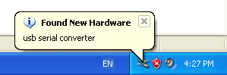
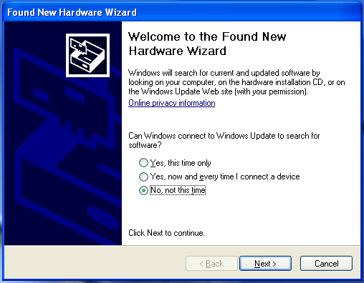
Step 3: Select “No,not this time”,click “Next” to continue.

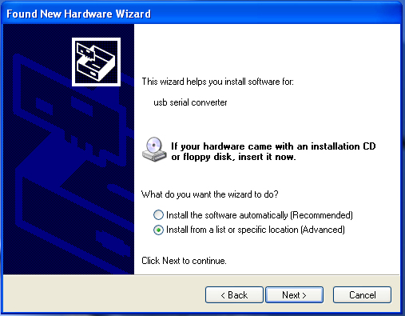
Step 4: Select “Install from a list or specific location(Advanced)”,click “Next” to continue.

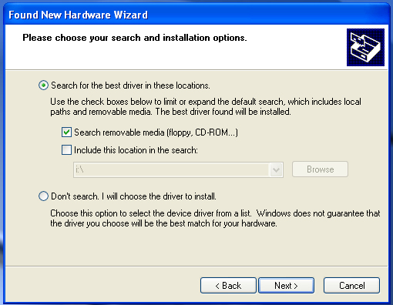

Step 5: Select “Search removable media(floppy,CD-ROD…)”, click “Next” to continue.

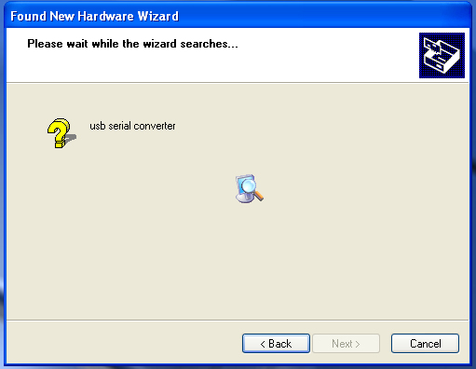
Step 6: Auto search for the corresponding driver in the CD.

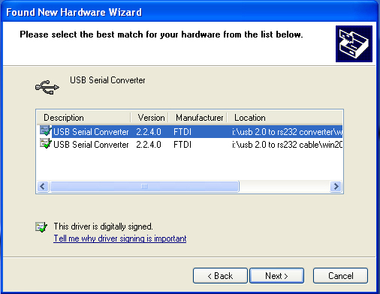
Setp 7: You will find two types of hardware wizard, one is for USB 2.0 TO RS232 Converter,another one is for USB 2.0 TO RS232 cable.please choose the corresponding driver according to your product ,click “Next” to continue.

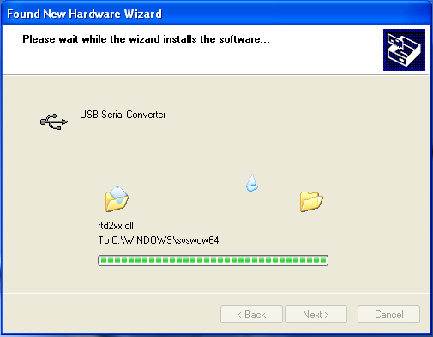
Step 8: The wizard has started insllation and copy file to your system

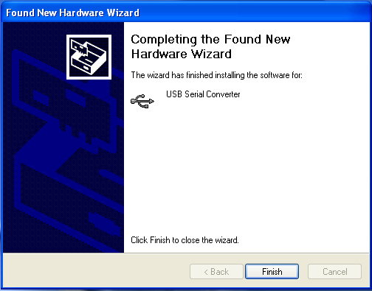

Step 9: Click “Finish” to close the wizard.

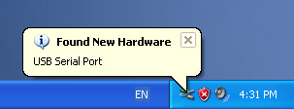
Step 10: Find new com port.

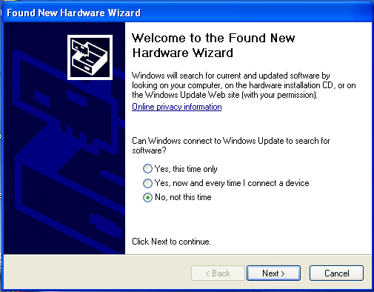

Step 11: Select “No,not this time”,click “Next” to continue.

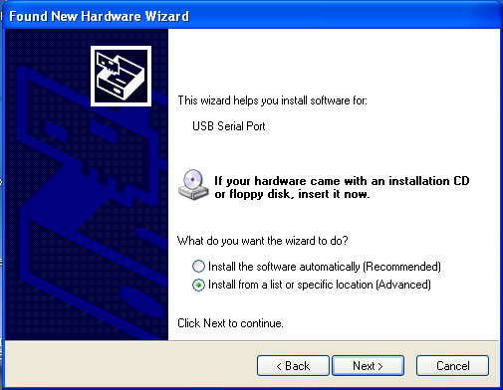

Step 12: Select “Install from a list or specific location(Advanced),click “Next” to continue.

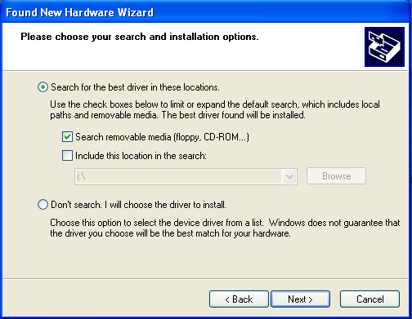

Step 13: Select “Search removable media(flappy,CD-ROM…)”,click “Next” to continue.

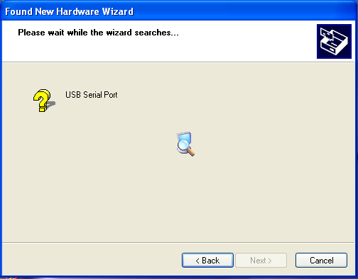

Step 14: Auto search for the corresponding driver in the CD.

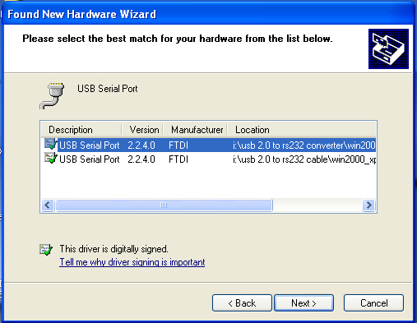

Setp 15: Choose one type of the driver for your product ,click “Next” to continue.

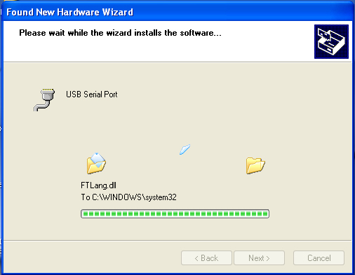
Step 16: The wizard has started insllation and copy file to your system .

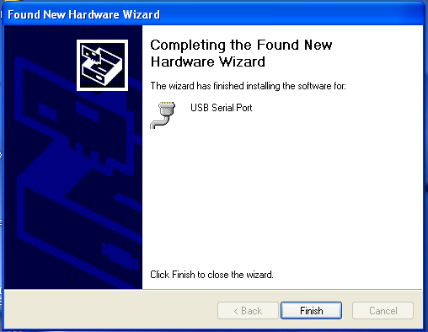
Step 17: Installation completed , click “Finish” to close the wizard.

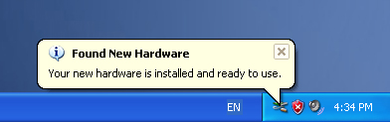

Step 18: Your new hardware is installed and ready to use.

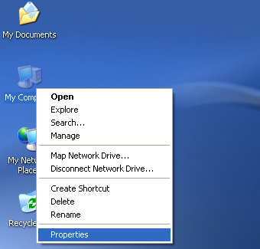

Step 19: If you want to see it, right click “ my computer” , then click “Properties”.

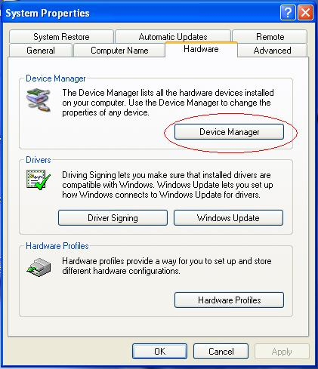

Step 20: Select “Device Manager” in the “Hardware” of the interface “System Properties”, click it, you can see the hardware devices installed on your computer , please refer to the following chart :

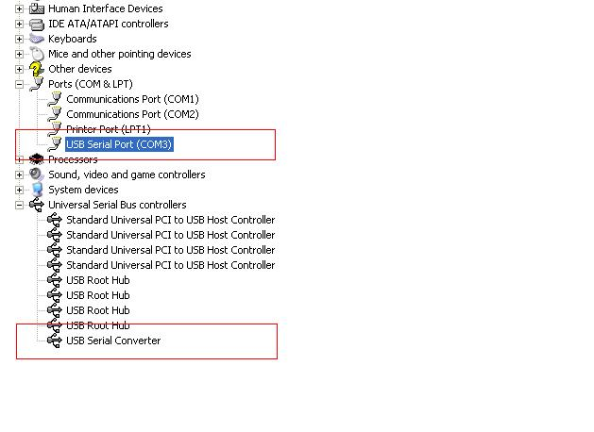
Step 21: Installation finished .

Remarks:
After installation , if you can see “USB Serial Converter” from the “Device Manager” ,but can’t see “USB Serial Port(COM3)” , please continue next steps.
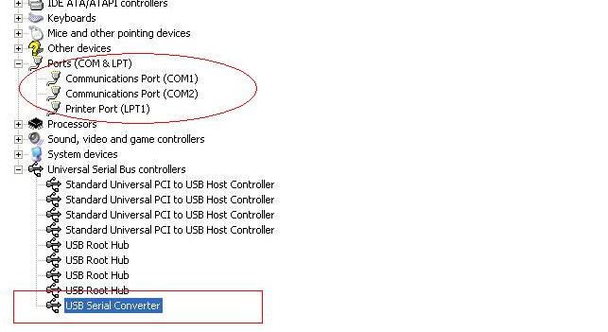

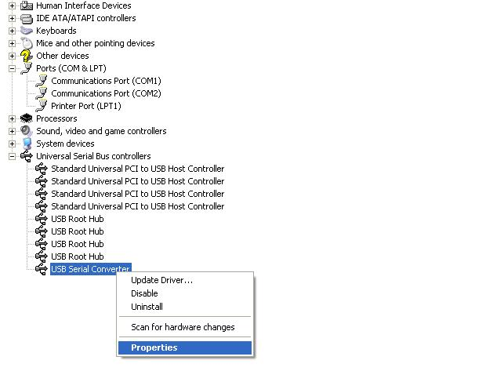
Step A: Right click “USB Serial Converter”, then click “Properties”.

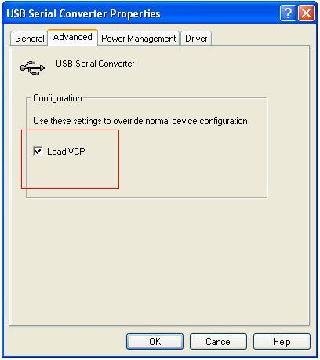

Step B: Select “Load VCP” in the “Advanced”, click “OK”.
Step C: Move out USB TO RS232 on your computer. Connect the device to an old USB port on your PC again, now it’s ok , please refer to the following chart:

Congratulations, installation is successful.

